**Brompton Electric review: A tiny folding ebike you’ll take almost everywhere**

It's so small, I never had to lock it outside

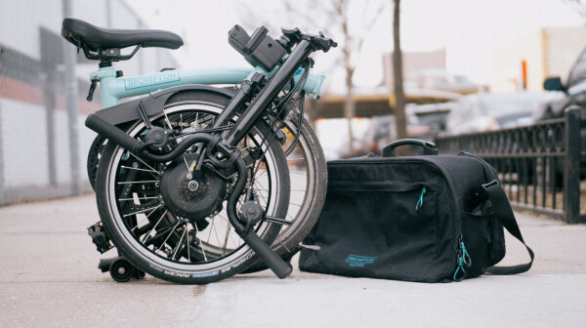

Electric bicycles can be the fastest way to get around a city like New York, but they can also be a pain when you’re not actively using the electric components.

For one, ebikes typically command large price tags that make them compelling targets for thieves; carrying two heavy duty locks with you everywhere is usually a minimum.

For another, they tend to weigh 50-70 pounds, making them a pain to manuever while not riding them. God forbid you need to carry your bike up a fifth floor walkup, or that your bike breaks down and you need to take it on the subway. And good luck going up mild inclines if your battery runs out.

That extra weight often makes storage in an apartment inconvenient too, as you’re unlikely to want to hang one on a wall or vertical bike rack. For all the conveniences of ebikes, they rarely come without significant caveats.

I say all this not to disparage ebikes, which I think are essential for the future of green transportation in cities. But rather, it’s to highlight just how awesome the Brompton Electric is. Able to fold down so small you can bring it almost anywhere, it has all the fun and power of a typical ebike, with none of the above issues.

It’s very pricey, starting at $3499, but it’s hard to put a price on some of the conveniences and peace of mind it affords you.

I’ve ridden several folding bikes before, but none that fold down nearly as compact. This is thanks to 16″ tires (most folding bikes use 20″ tires) a clever three-part frame (most folding bikes just have a frame split down the middle), and an easily-removable cargo bag which contains the battery. The Brompton Electric is just 22.2″ x 23″ x 10.6″ (565 x 585 x 270mm) when folded. That’s just a little wider than an overstuffed carryon bag, and visually the footprint is an even smaller.

Here’s how the fold works:

Because the battery bag is meant to be removed when bringing the bike indoors, the 6-speed option I reviewed weighs just 32 lbs, less than the superlight Specialized Turbo Vado SL I reviewed a few months ago. Granted, the battery bag adds another ~7 lbs, but you hardly feel it as the bag is meant to be strapped around your shoulder when not riding the bike. Even the combined weight is less than the vast majority of ebikes on the market, and the two-speed option shaves off another couple of pounds.

By comparison typical electric folding bikes tend to hover around 35″ x 28″ x 17″ and 50-60 lbs, let alone some popular fat-tire models. Moreover, Brompton’s folding mechanism has been largely unchanged since the bikes were introduced in the 70s; the company built its reputation on the compactness and durability of its fold.

On paper, the Brompton Electric’s folded size may not seem like that much of a big deal, but it made a dramatic impact on my riding (and peace of mind). It’s small enough that I opt to always keep it in my small apartment rather than the storage room where the rest of my review bikes are. Moreover, in two months and hundreds of miles of riding three or four days a week, I’ve never had to lock up the bike. The only time I did lock it up was just to test where I’d fit the U-lock if I had to (some tips in this video).

PLEASE LOOK AT THE FULL ARTICLE AT:

<https://thenextweb.com/shift/2021/02/26/brompton-electric-review/>