**Change Your Screen to Grayscale to Combat Phone Addiction**

Melissa Kirsch 2/18/20

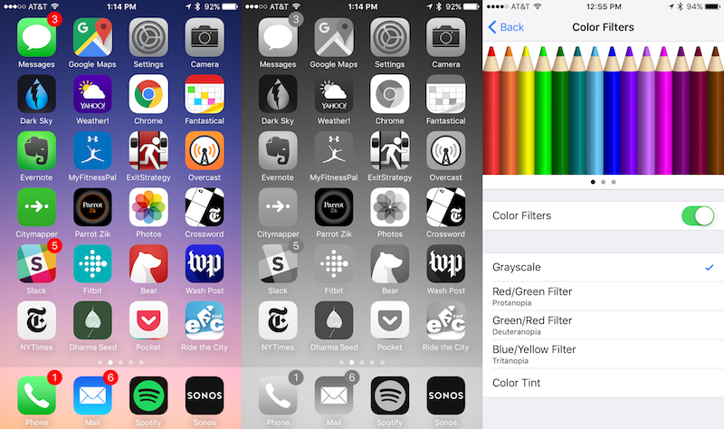

If you find that it’s hard to look away from your phone, there’s a good reason for that: it was designed that way. A few years ago, former Design Ethicist at Google and founder of the non-profit Time Well Spent Tristan Harris made the rounds, talking about how technology is engineered to be addictive and hijack our attention. He was pretty persuasive, and compared the lure of your phone to the that of a slot machine.

Most of the time, you check your phone and there’s nothing interesting—no notifications, just the same old apps staring back at you. But sometimes checking your phone is rewarding —you get an amusing text, a flurry of likes, an email containing good news. This hit is satisfactory enough to keep you returning, checking your phone compulsively for another dopamine jolt.

Illustration for article titled Change Your Screen to Grayscale to Combat Phone Addiction

This App Helps You Curb Your Smartphone Addiction

We’re all probably a little more addicted to our phones than we’d like to be. I know that I…

Read more

Go gray

To combat phone addiction, Harris suggests enabling grayscale on your phone. It might not cure your addiction completely, but certainly Instagram and Snapchat are going to be a lot less appealing in black and white than they are in technicolor.

The process for enabling grayscale differs for different models of Android phones, but it’s typically accessed via the “Accessibility” menu. For example, in iOS, go to Settings > General > Accessibility >Display Accommodations >Color Filters. Switch Color Filters on and select Grayscale. To easily toggle between color and grayscale, go to Settings > General > Accessibility > Accessibility Shortcut > Color Filters. Now, you just press the home button three times to enable grayscale. Triple-click again to go back to color.

Image by Lifehacker.

Image by Lifehacker.

Illustration for article titled Change Your Screen to Grayscale to Combat Phone Addiction

How to Use Your Phone Less, According to Reddit

If you’re looking to cut down on how much you use your phone, redditor mukalodric has some…

Read more

If this doesn’t quite do the trick for you, we have other suggestions to help you kick the phone habit, like using certain apps and these tips from Reddit.

This story was originally published in 2017 and updated with new information on 2/18/2020.